Other names for Jesus in the Holy Eucharist:

- Holy Communion

- Eucharist

- Body and Blood of Jesus Christ

- Blessed Sacrament

- Bread of Life

- Food of the Angels

- Holy Meal

- Living Bread

- Lamb of God

- Sacred Host

- Sacrament Most Holy

- Sacrament Divine

- Bread of Heaven

- My God and My All

- Most Pure Feast
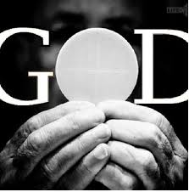
- Mystery of Faith

